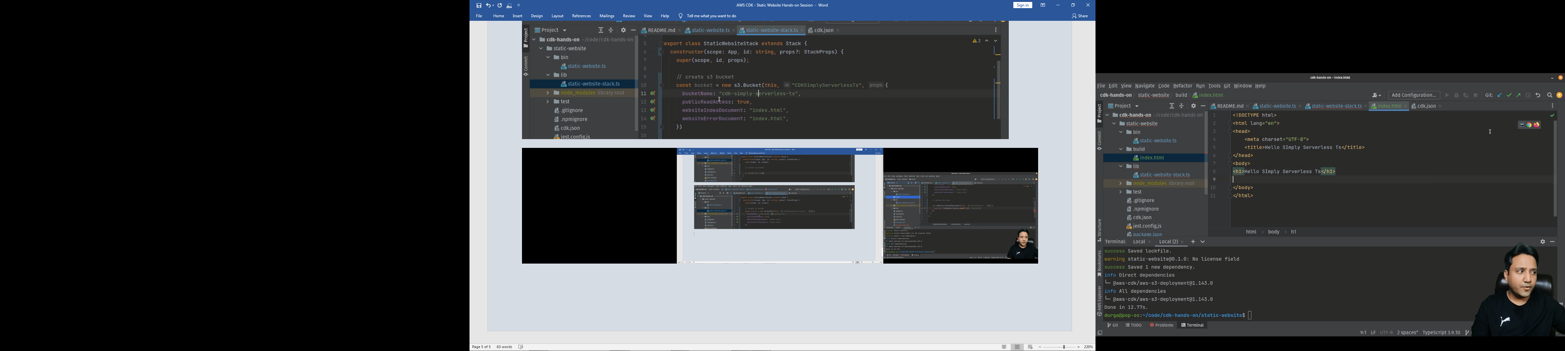

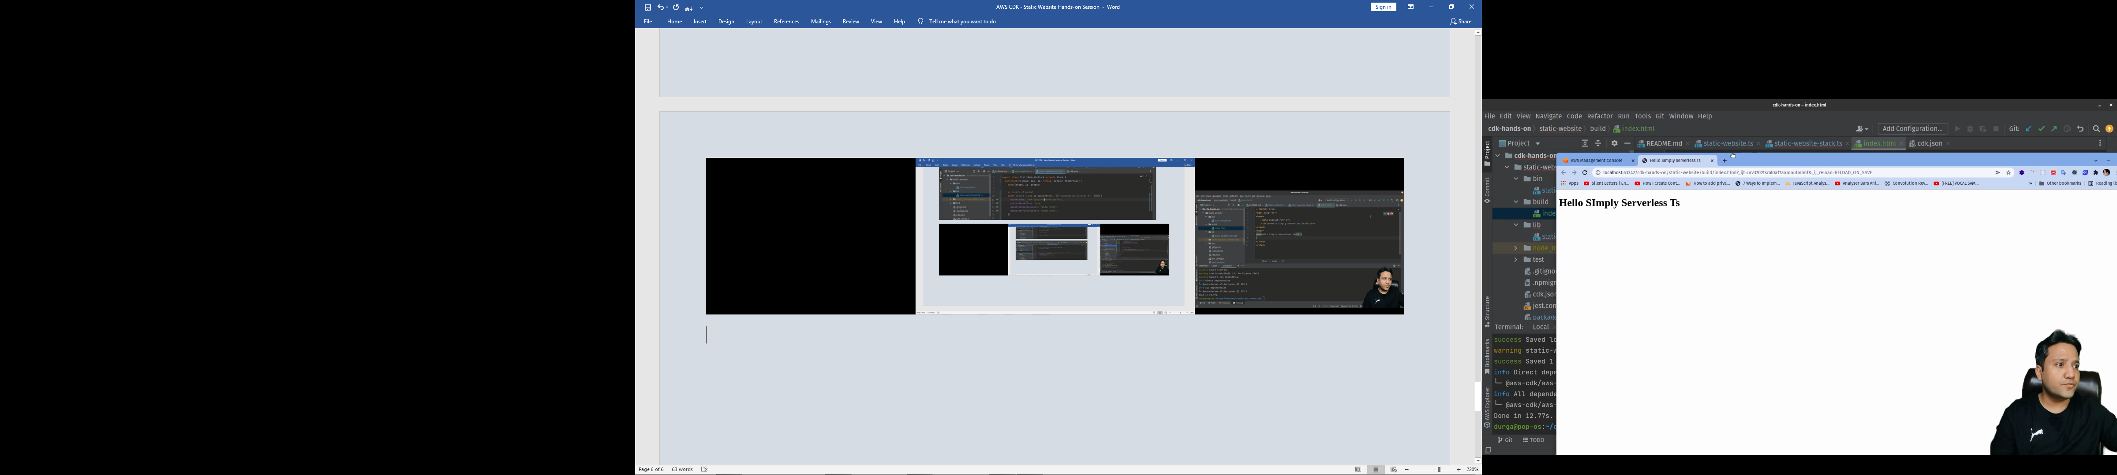

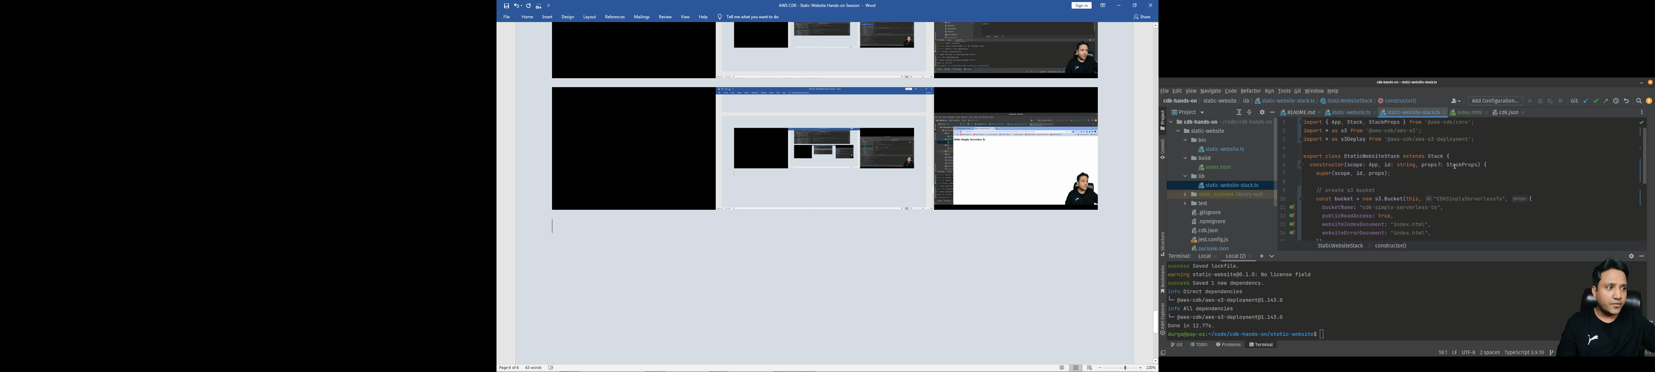

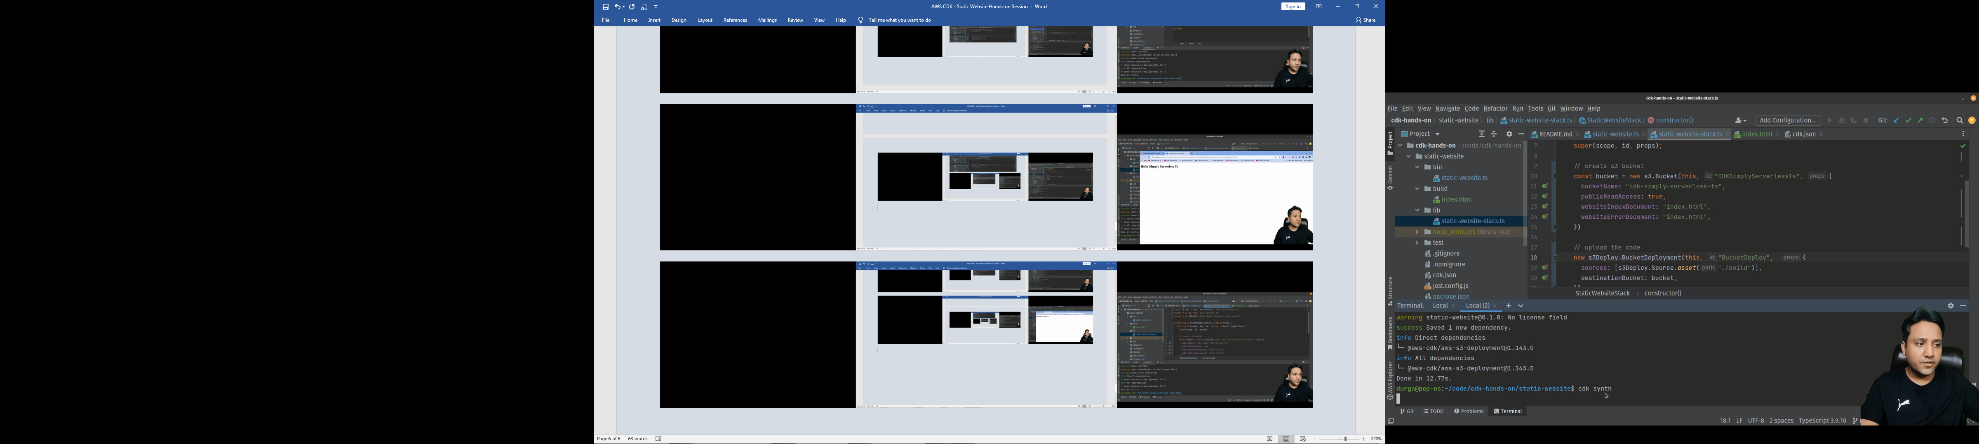

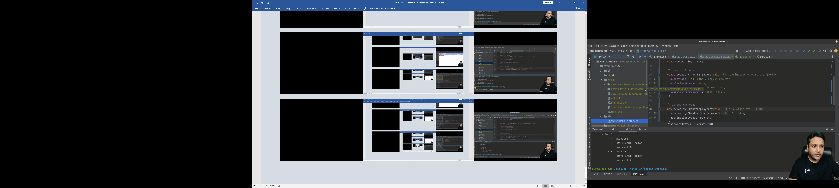

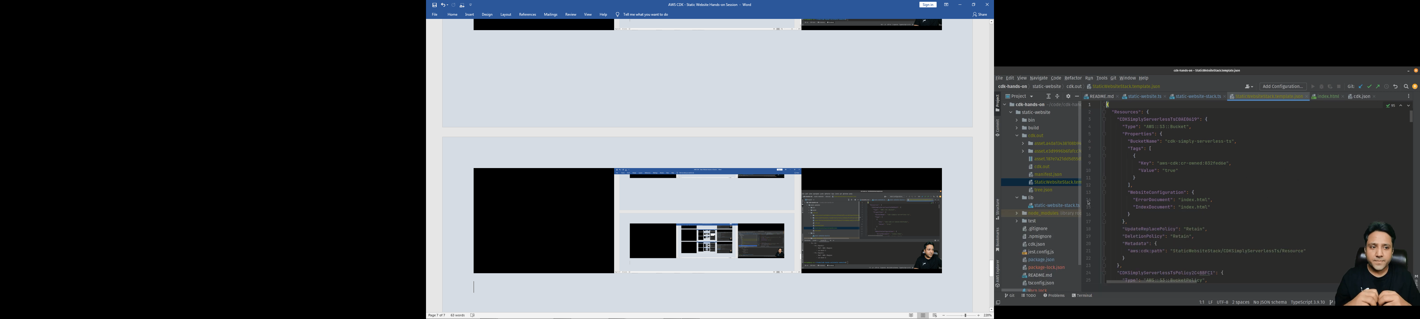

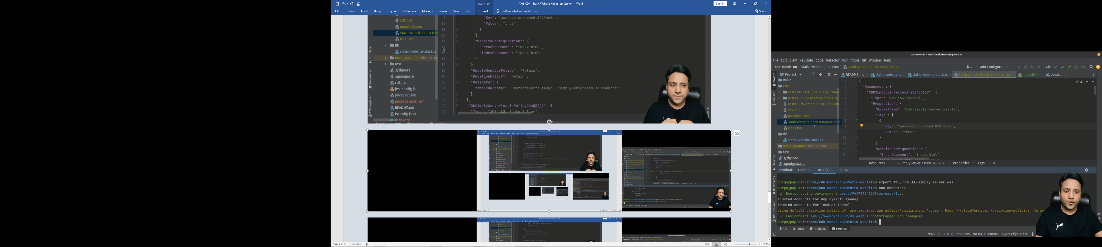

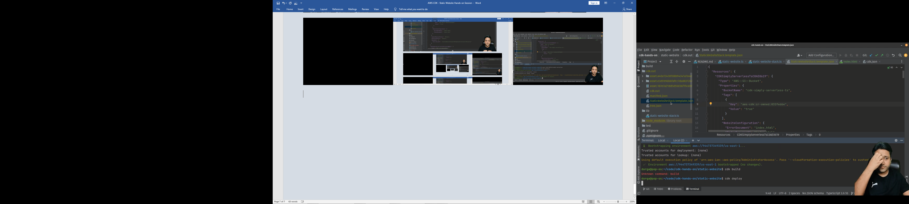

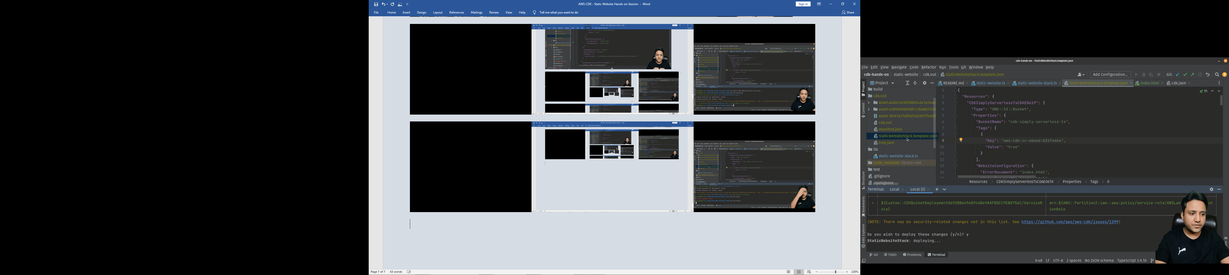

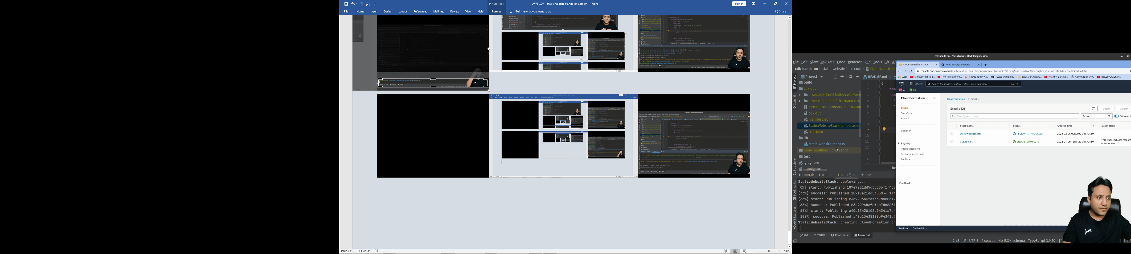

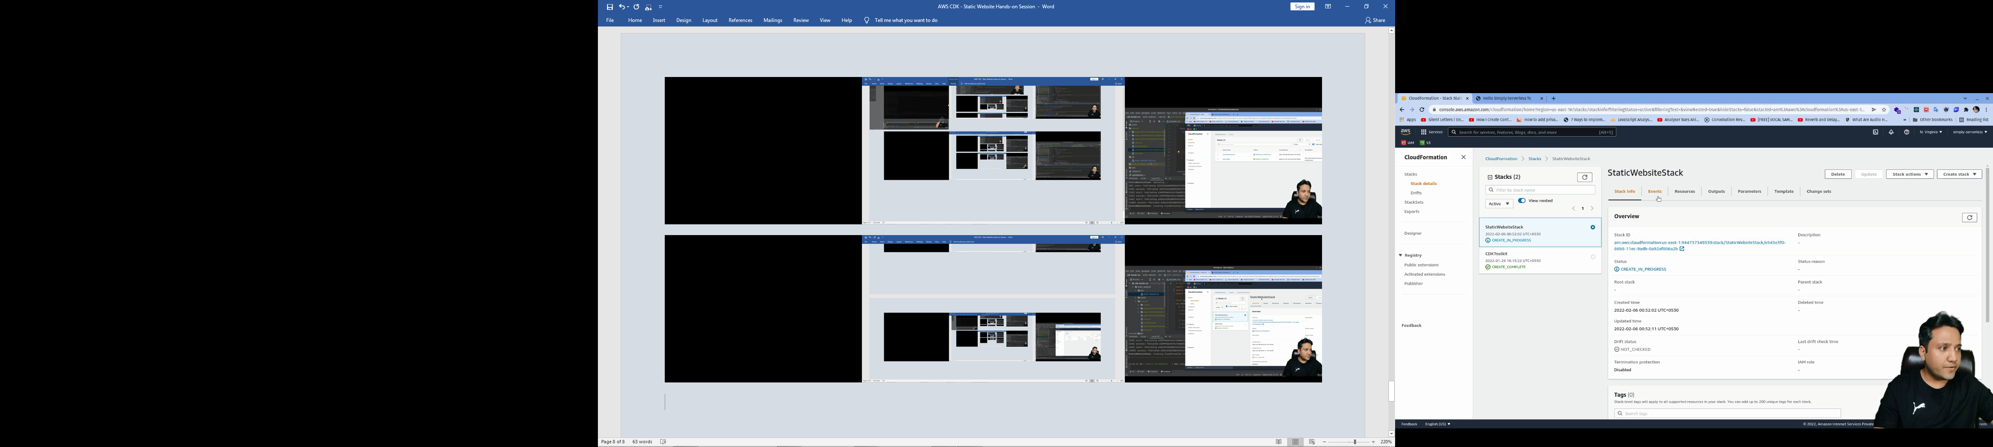

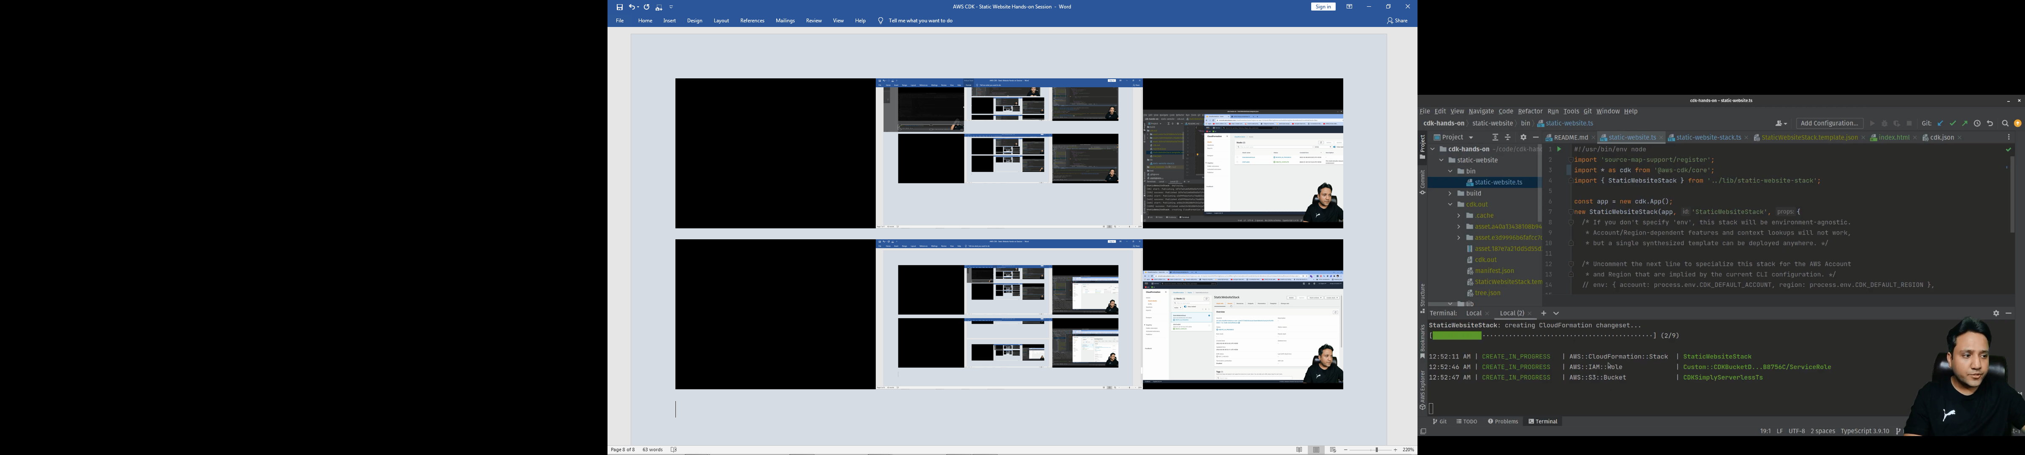

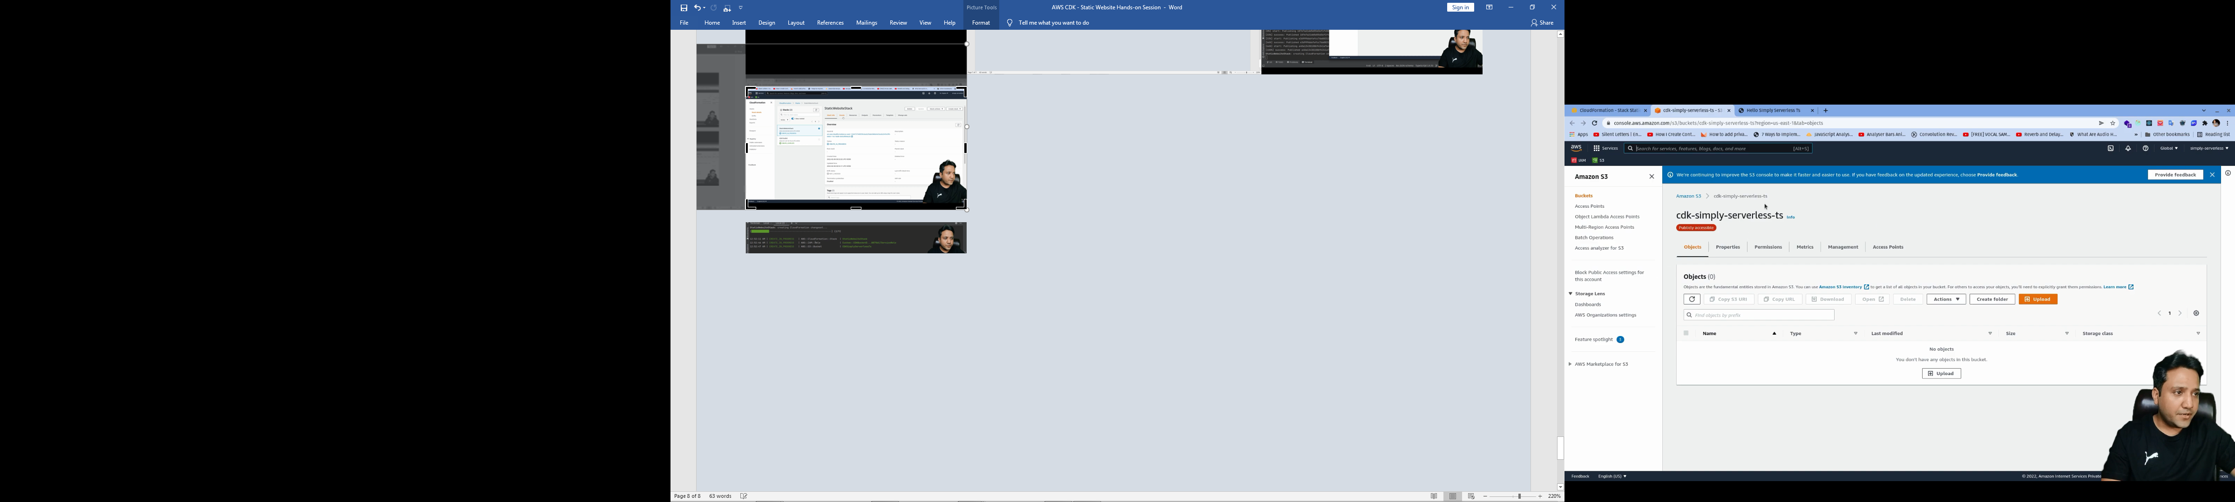

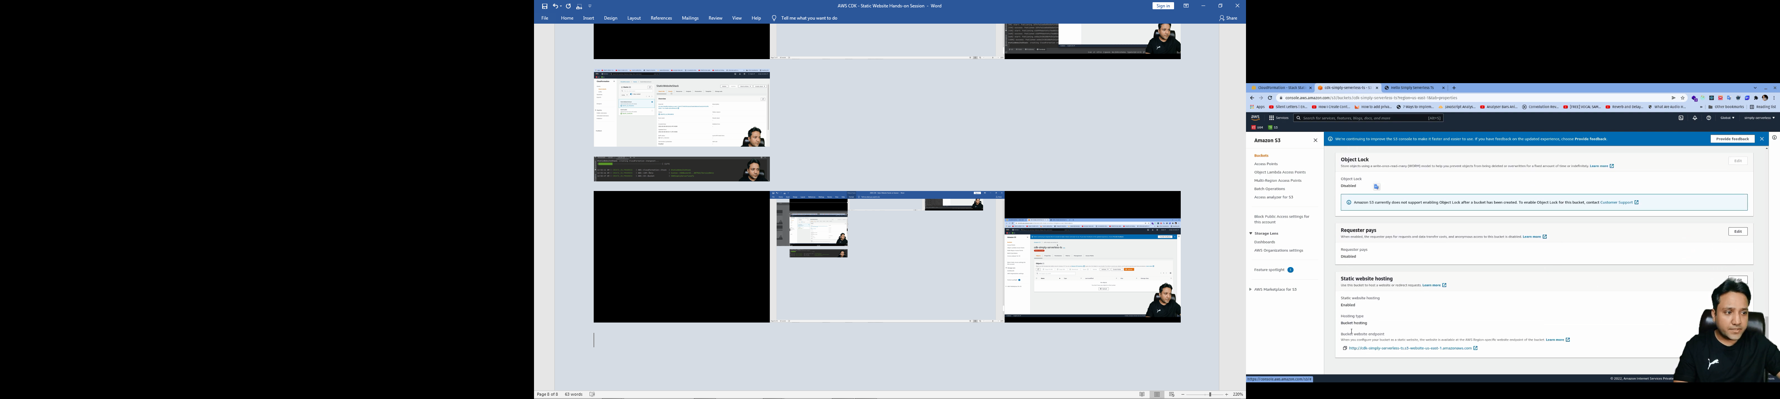

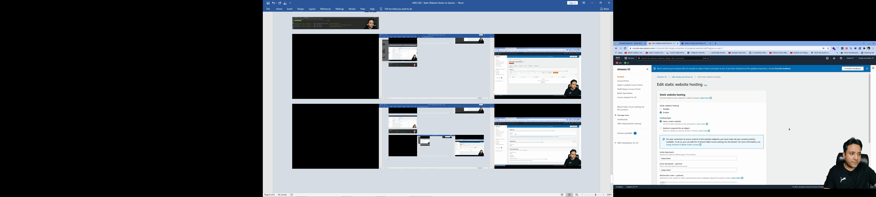

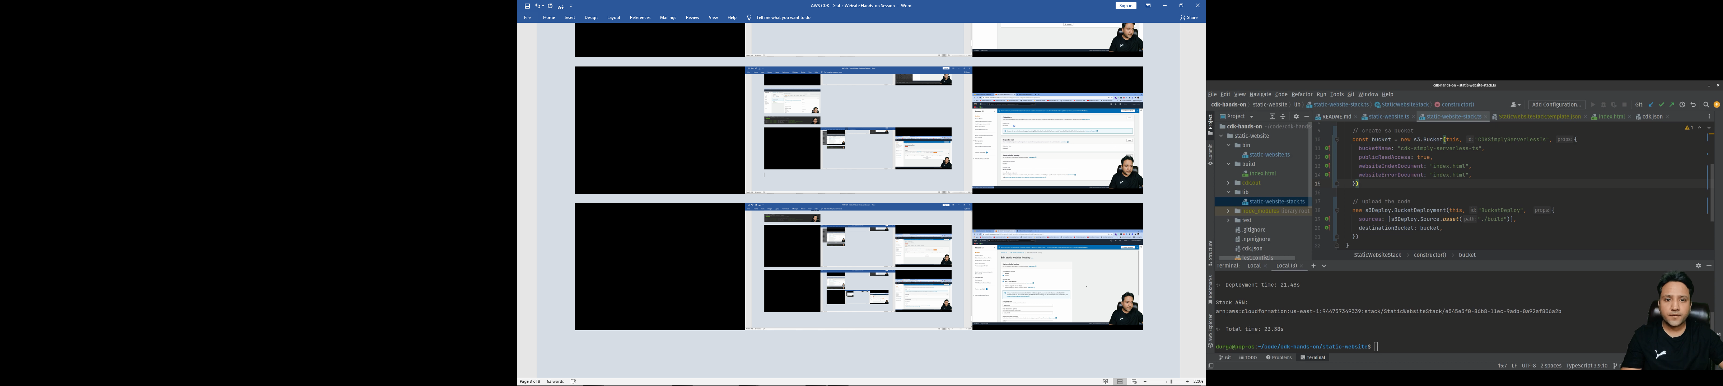

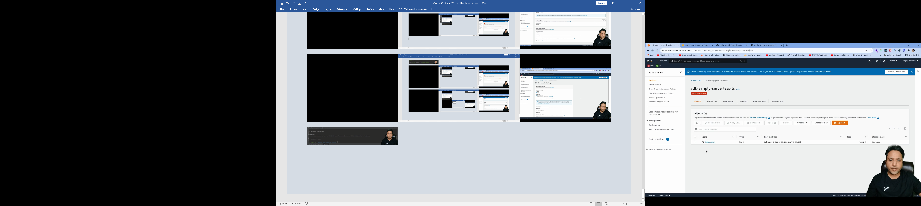

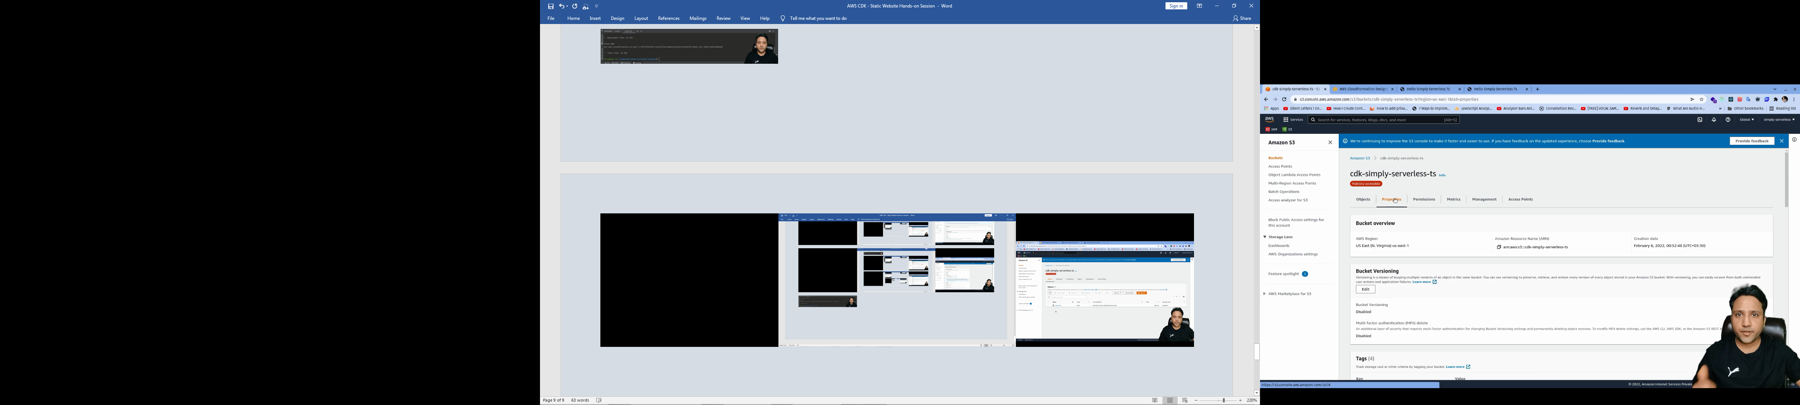

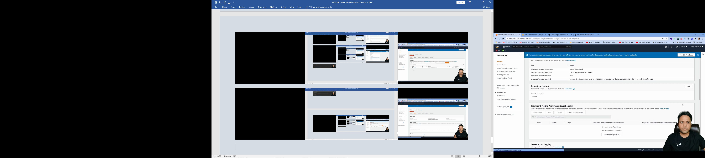

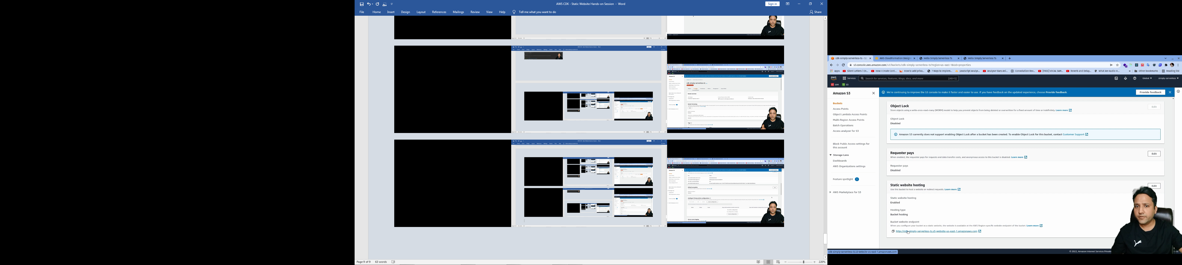

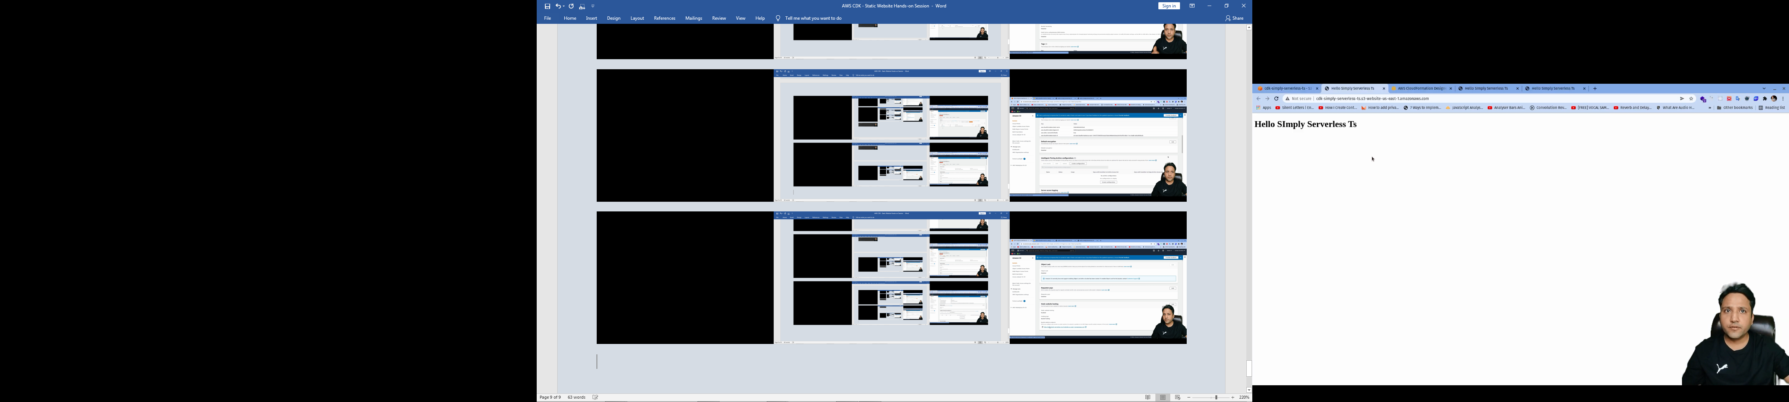

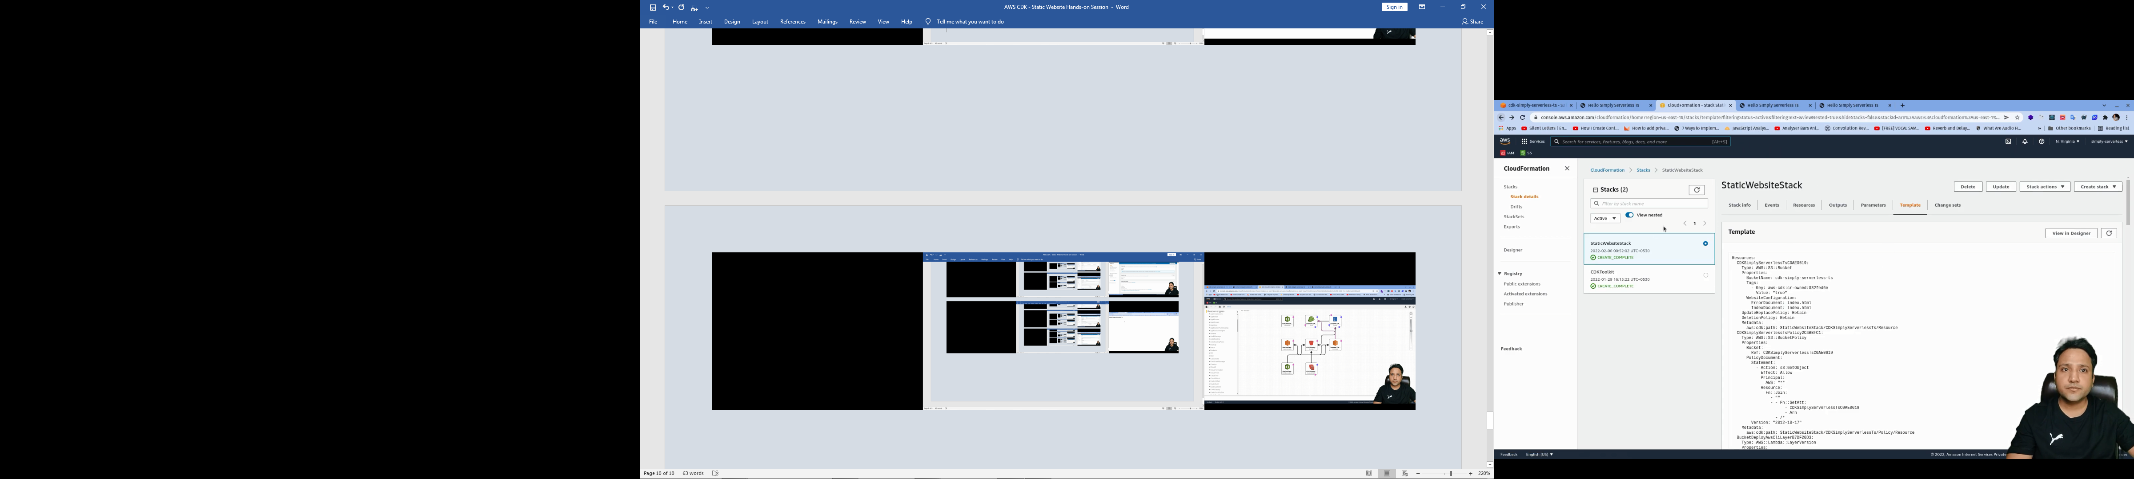

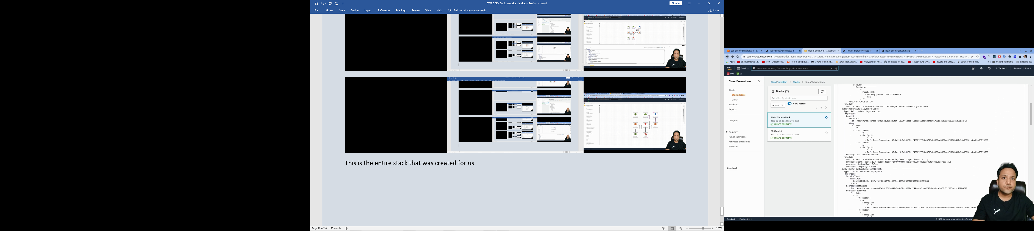

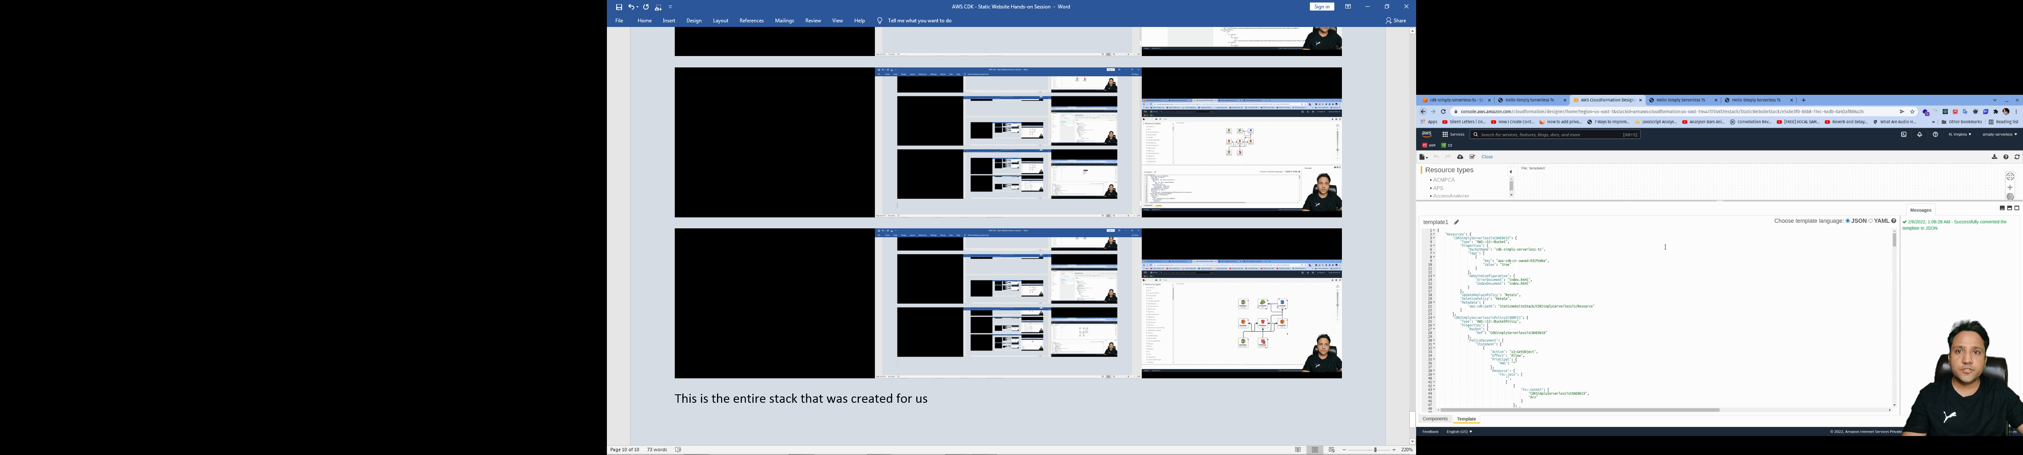

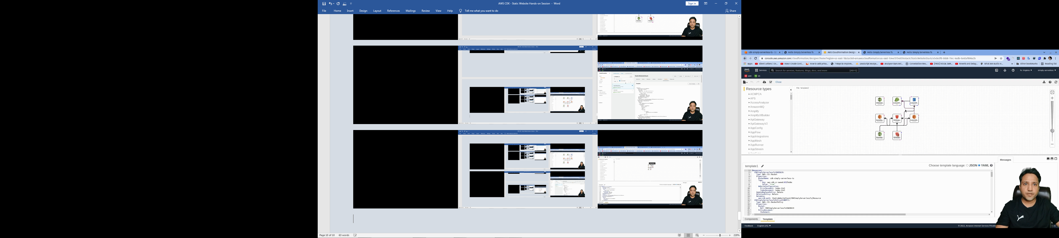

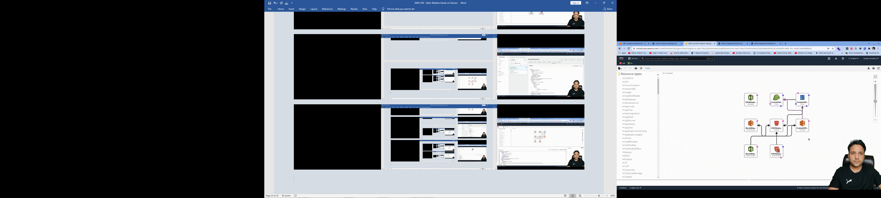

This is the entire stack that was created for us